第四章 线性方程组

1000A

知识点：

行变换与列变换：
https://chatgpt.com/g/g-p-6a1d6c6f0a408191a175c887909fceb5-xian-dai-he-gai-lu-lun-ocr/c/6a75acf8-eaac-83ee-8743-d1abe7bf6248

解空间维数：
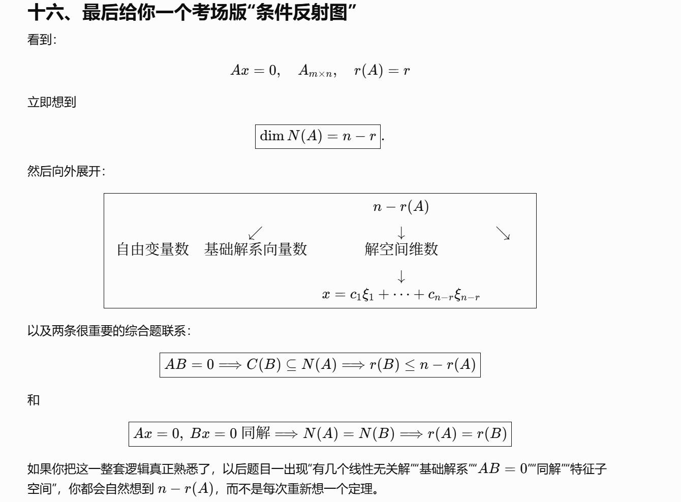
https://chatgpt.com/g/g-p-6a1d6c6f0a408191a175c887909fceb5-xian-dai-he-gai-lu-lun-ocr/c/6a804924-8bac-83e8-b47b-76f1c3b64a06

矩阵与几何：
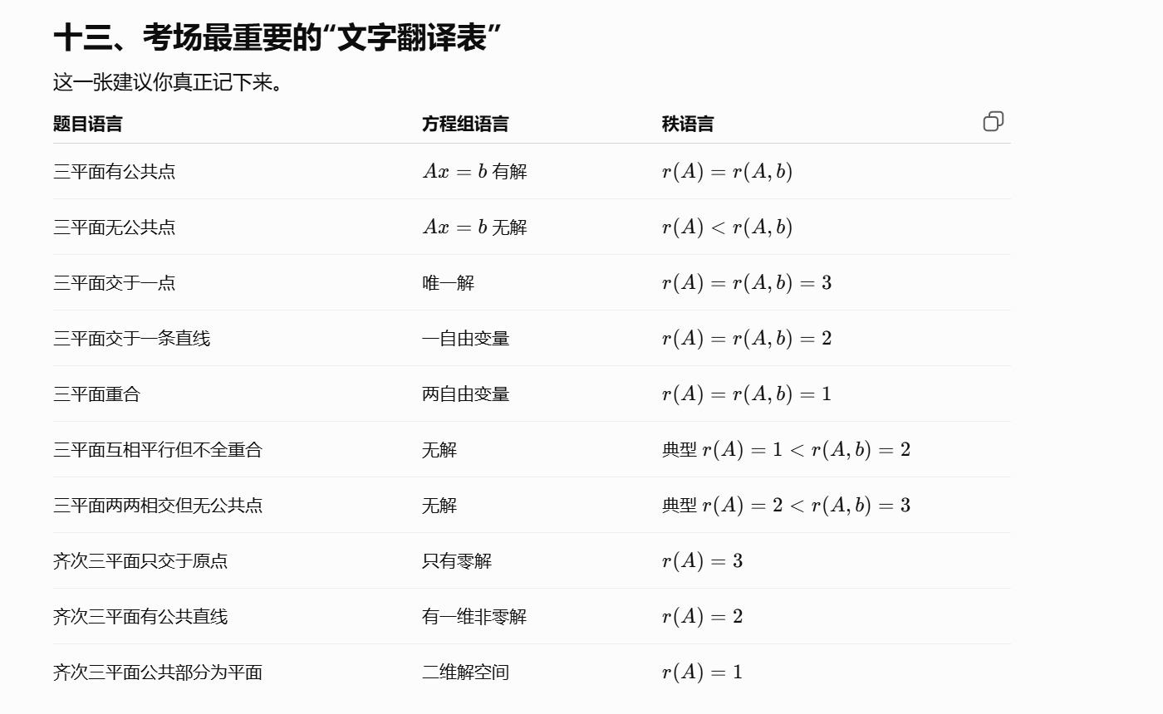
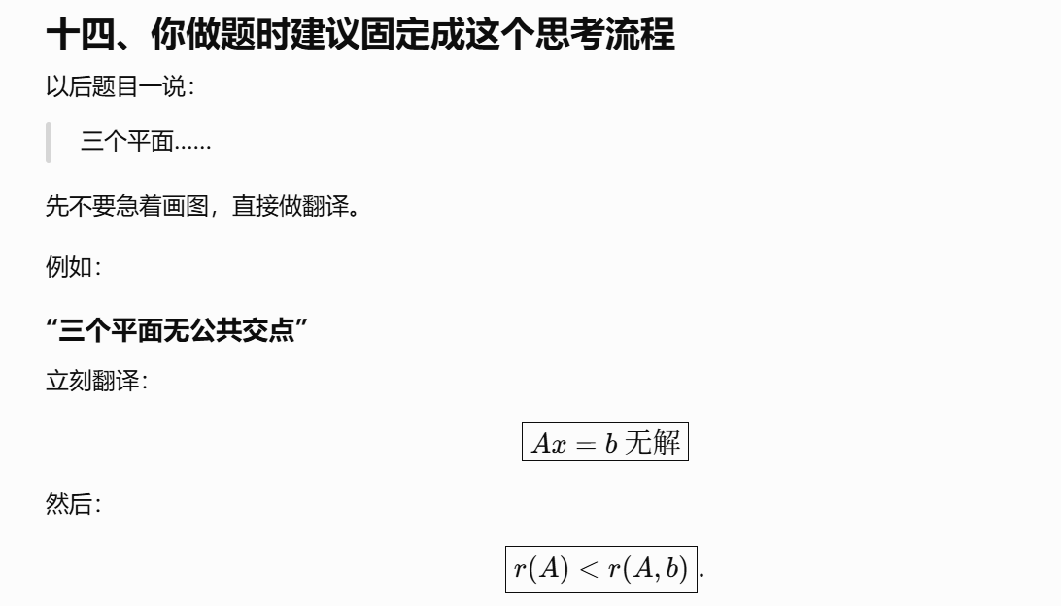
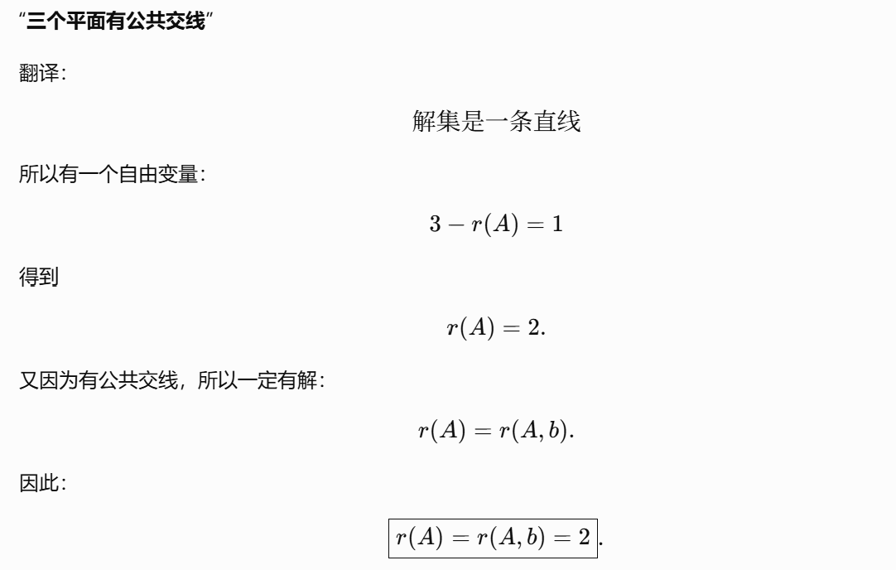
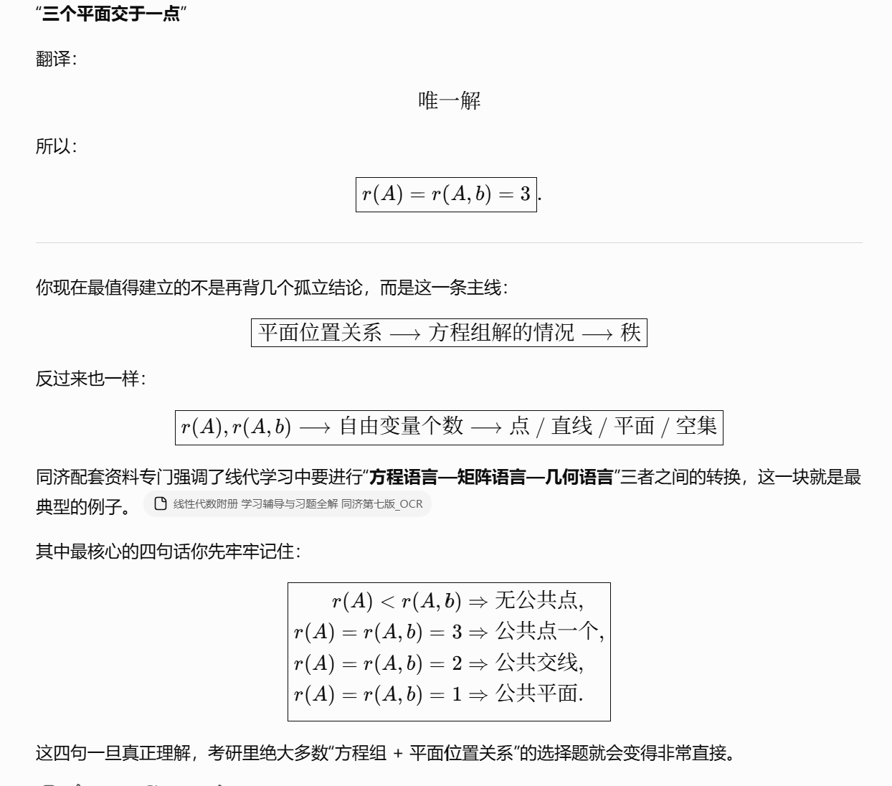
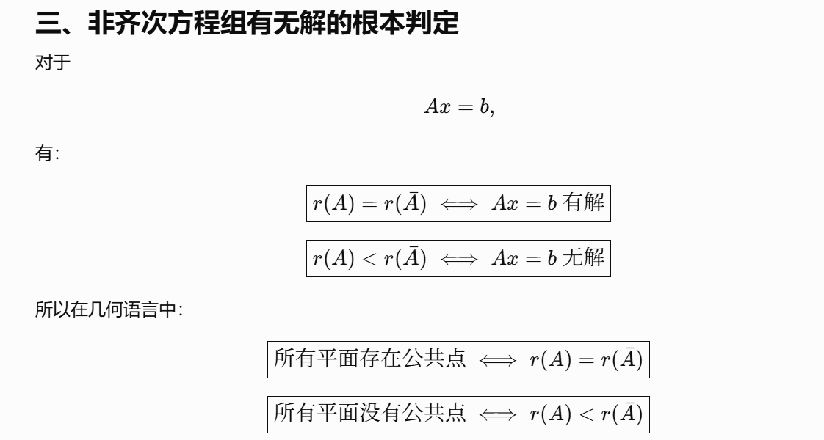
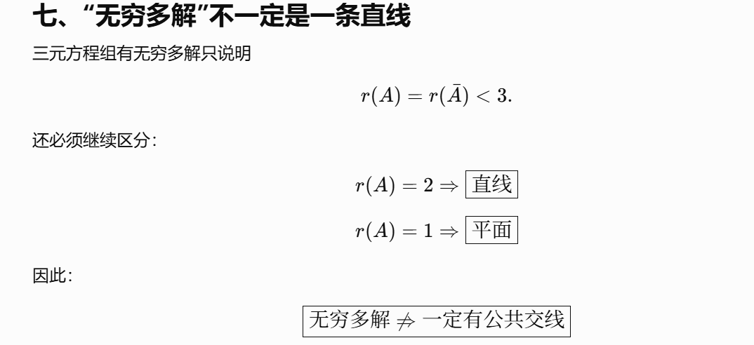
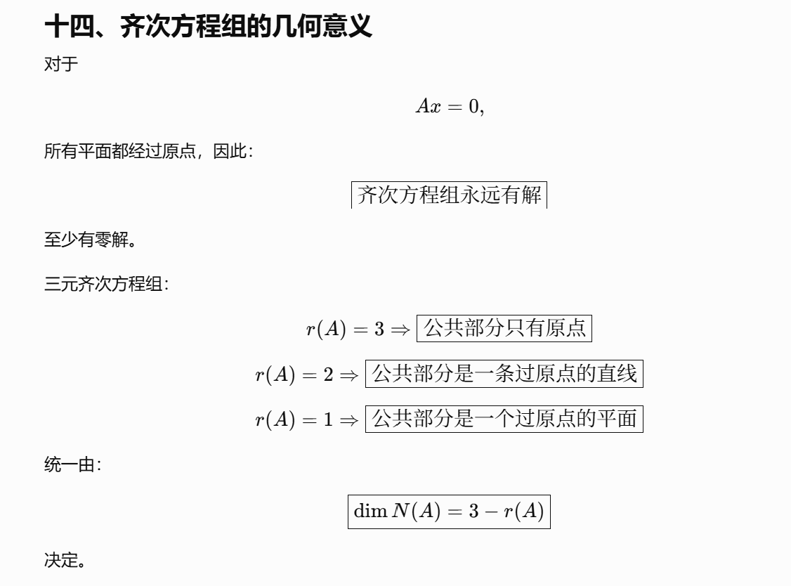
https://chatgpt.com/g/g-p-6a1d6c6f0a408191a175c887909fceb5-xian-dai-he-gai-lu-lun-ocr/c/6a80472e-184c-83e8-9106-39eca1cfdacb

概念：

等价：
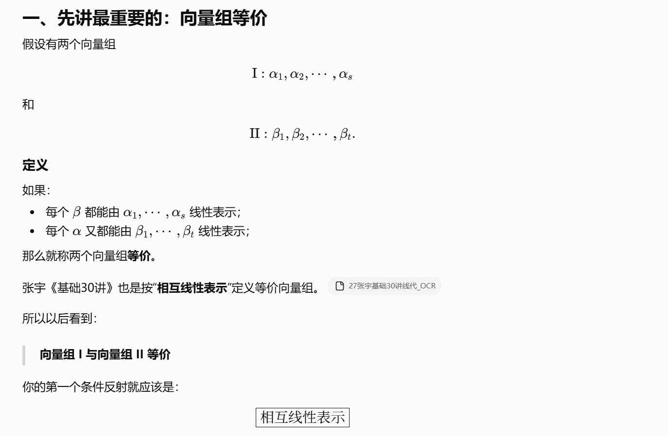
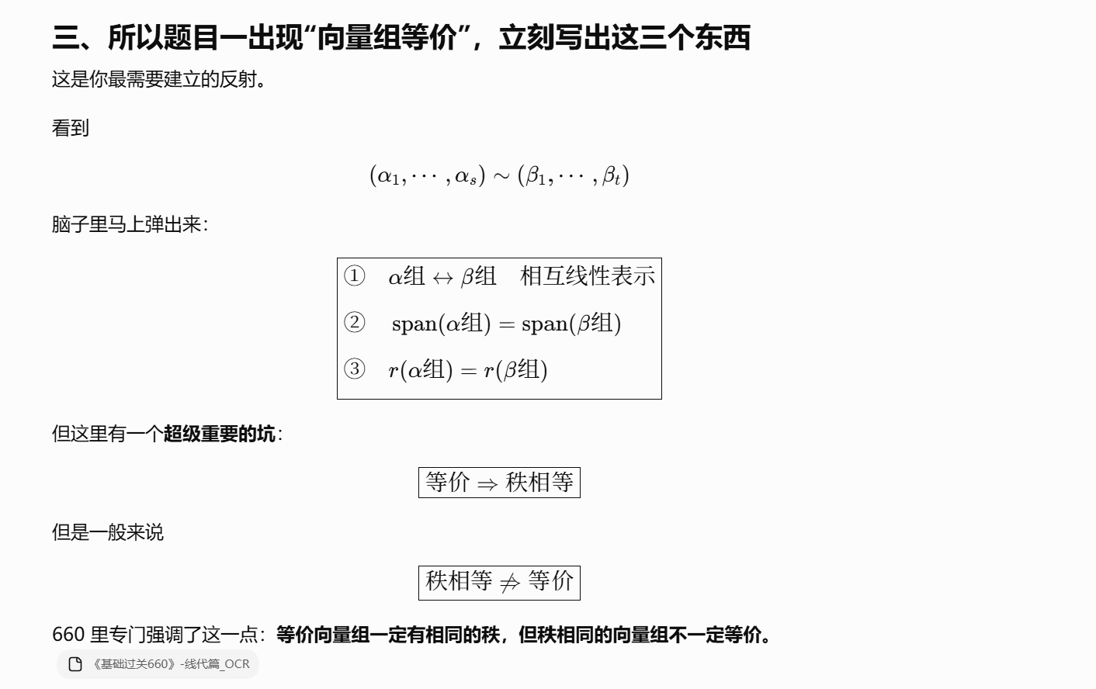
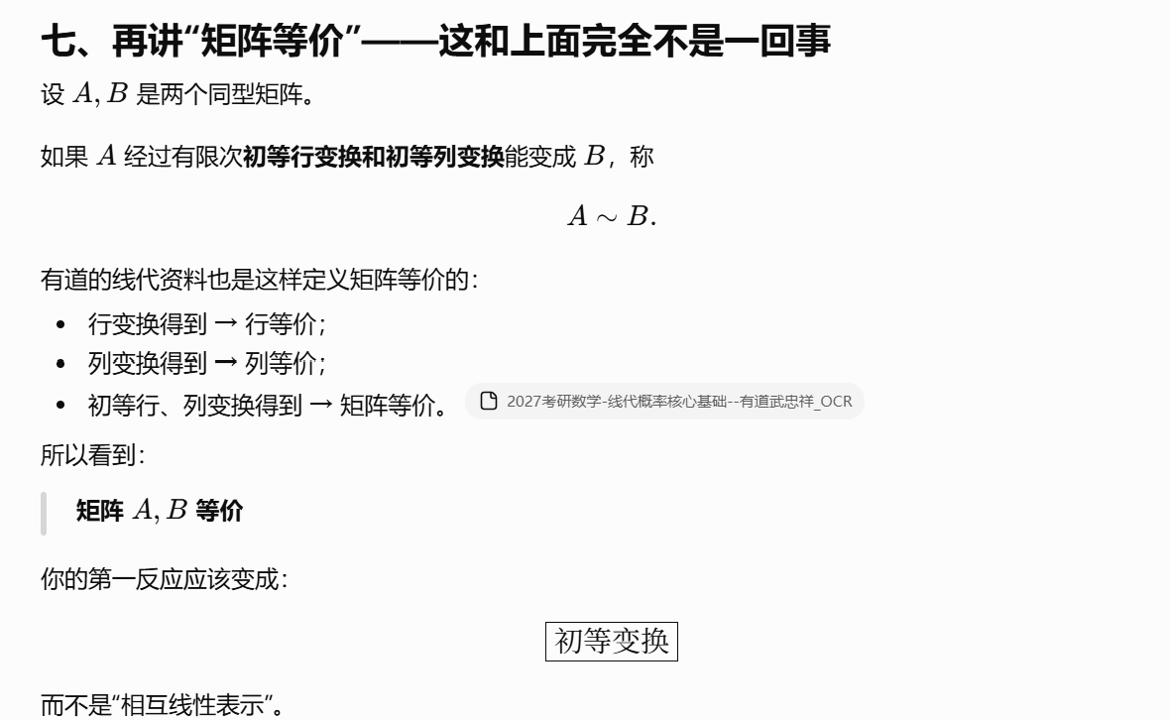
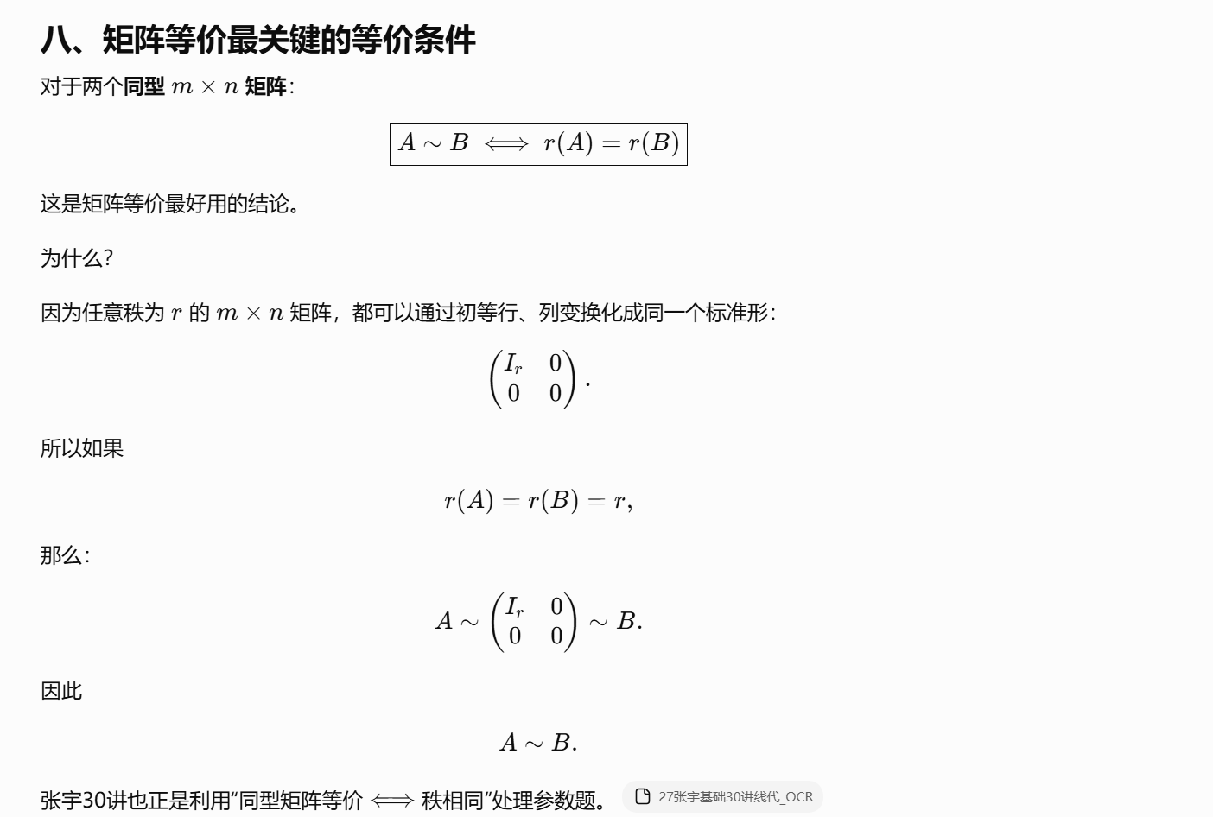
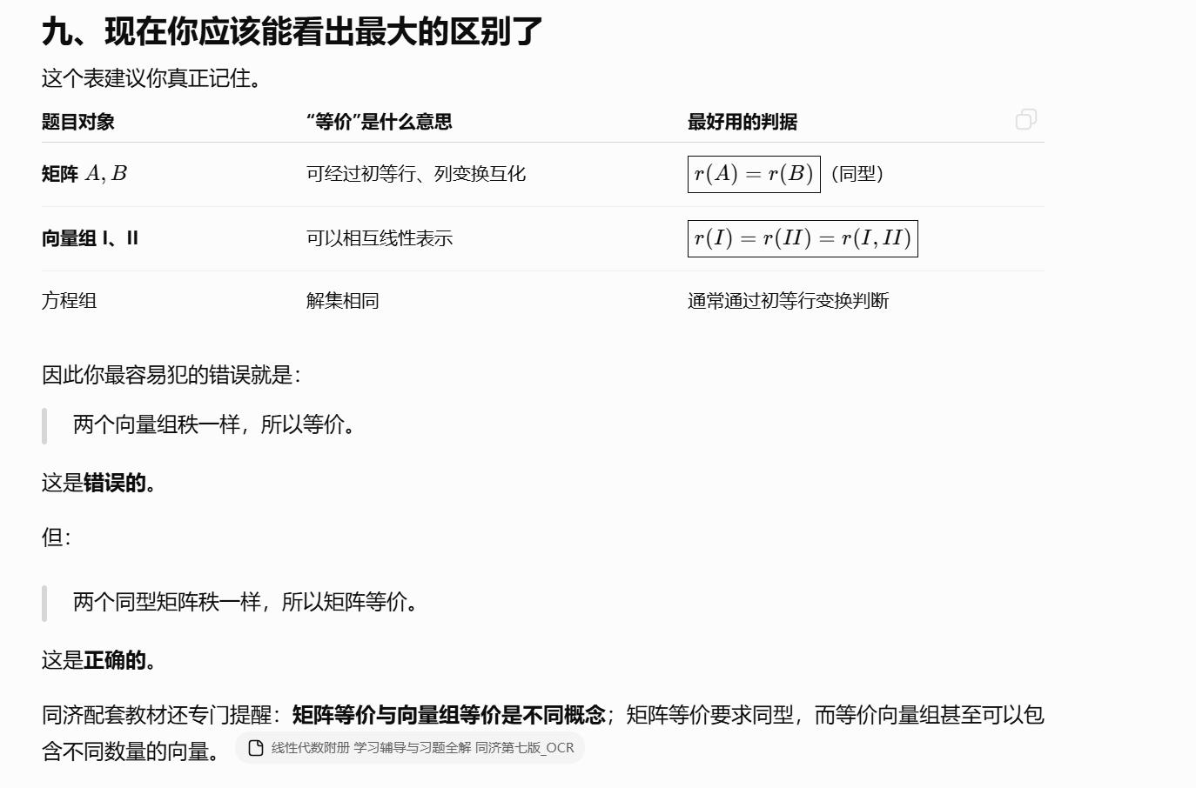
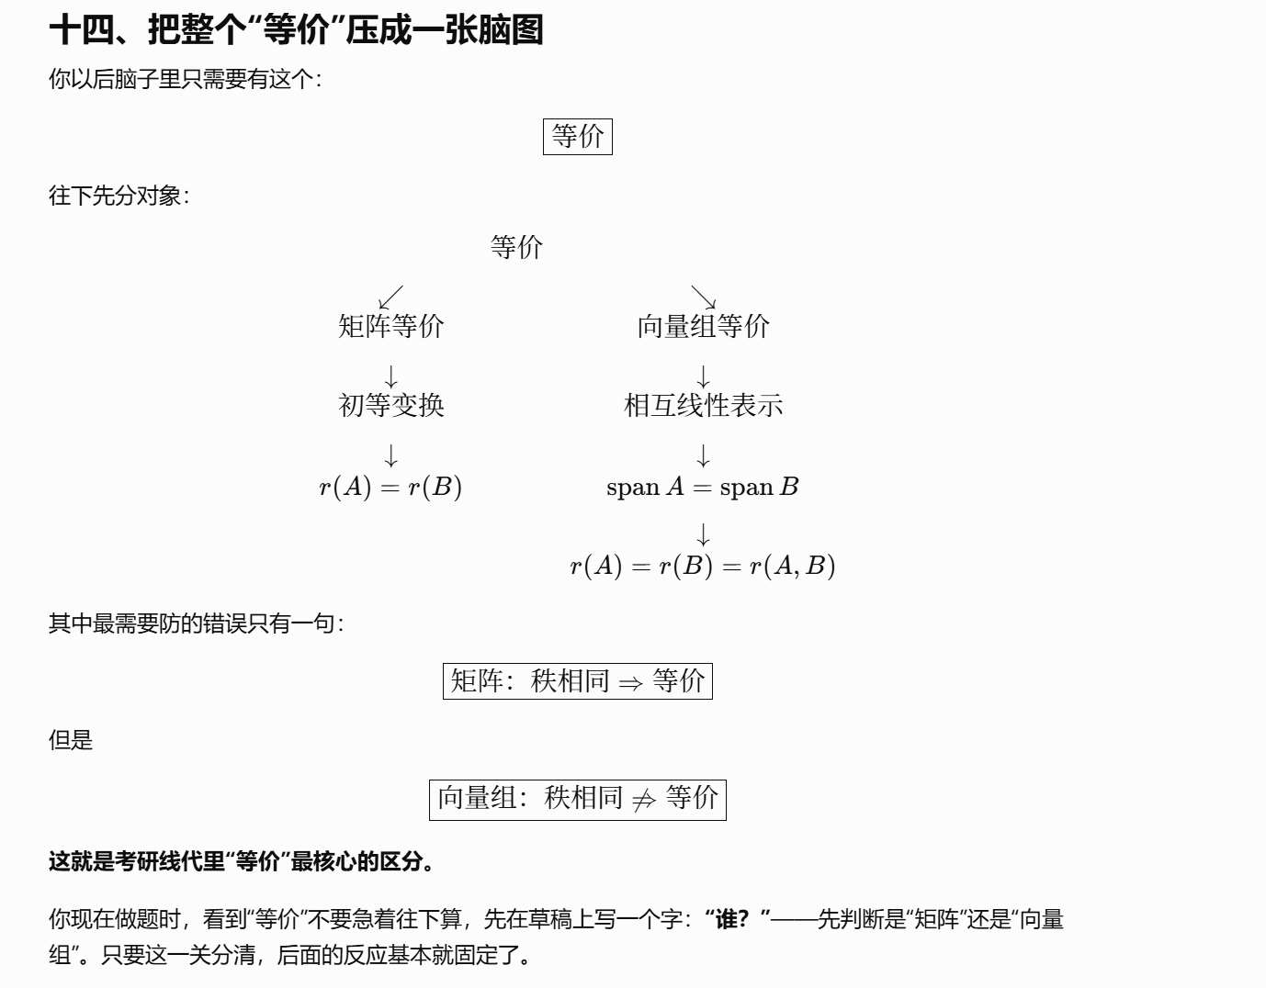
https://chatgpt.com/g/g-p-6a1d6c6f0a408191a175c887909fceb5-xian-dai-he-gai-lu-lun-ocr/c/6a80361f-438c-83e8-b5d1-6d5479c33316

正交补：
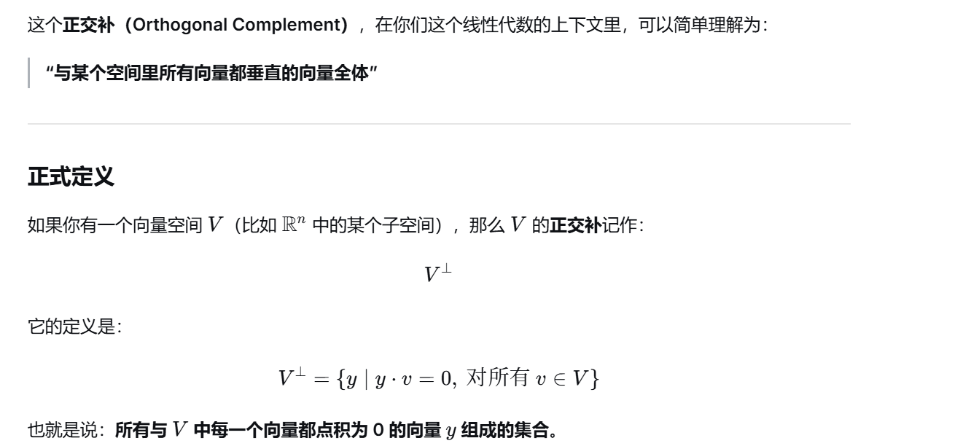

内积：
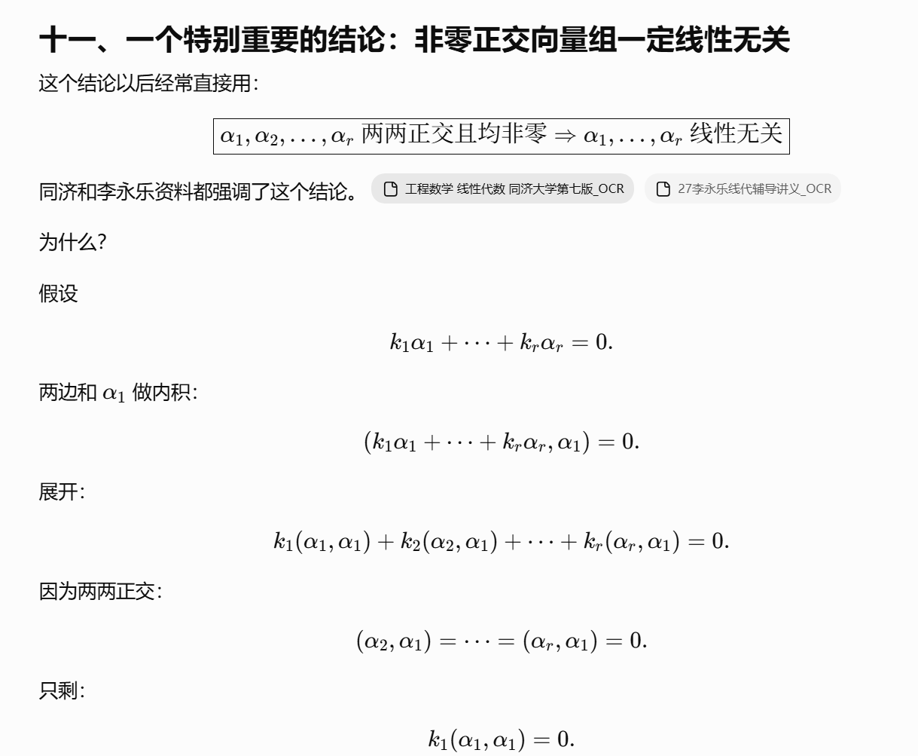
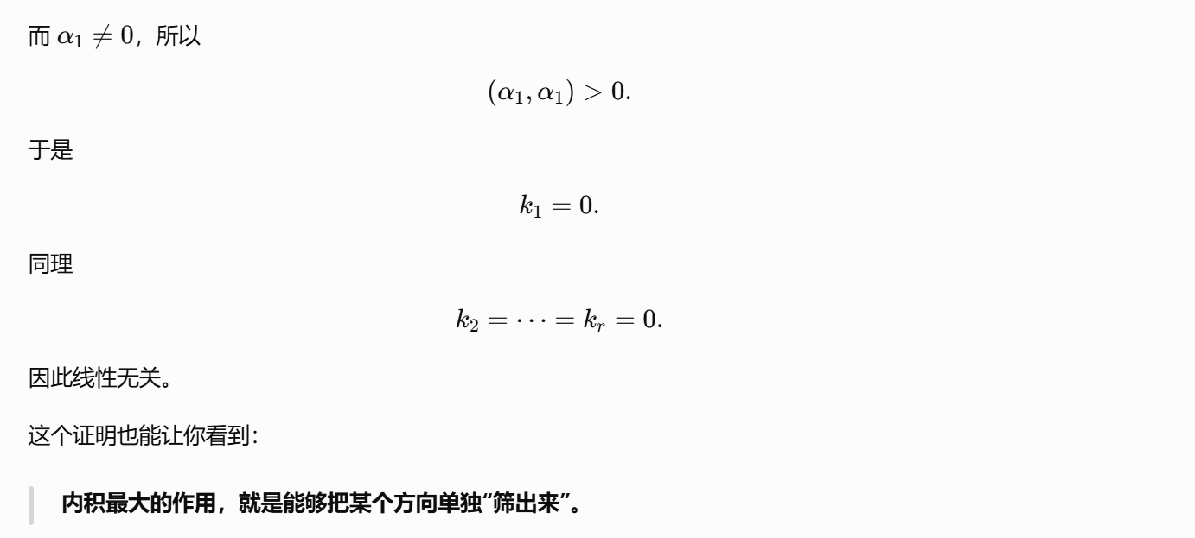
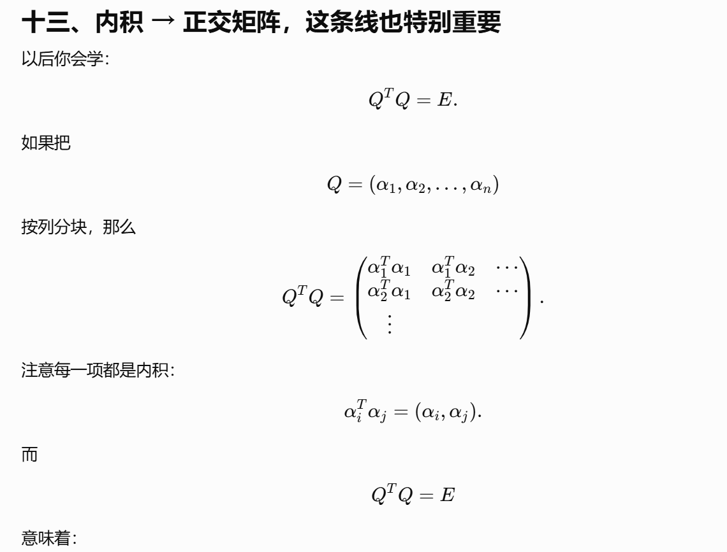
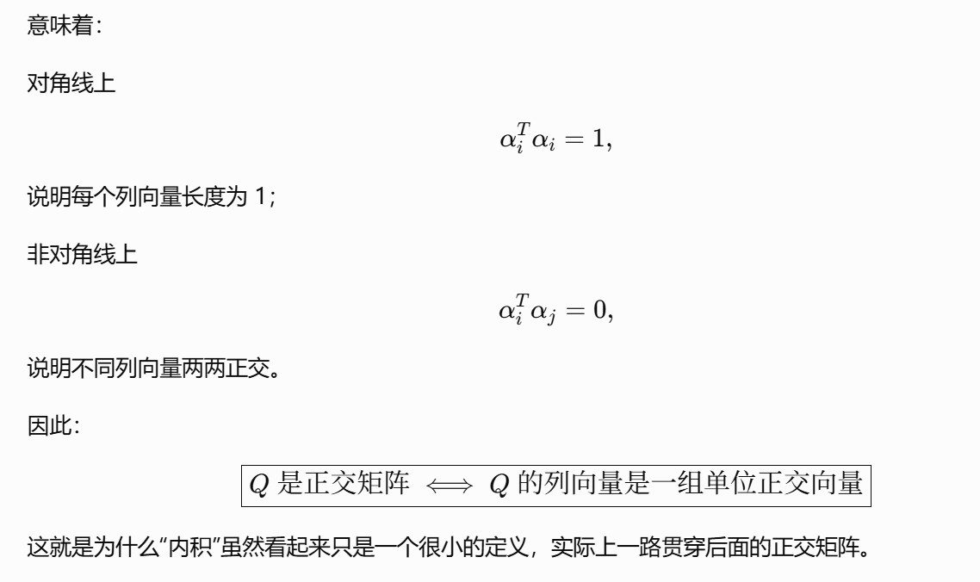
https://chatgpt.com/g/g-p-6a1d6c6f0a408191a175c887909fceb5-xian-dai-he-gai-lu-lun-ocr/c/6a8038e3-6390-83e8-94aa-b77f658f14fb

题：

题1：
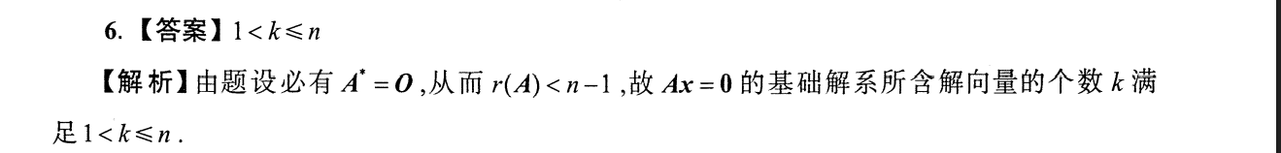
https://chatgpt.com/g/g-p-6a1d6c6f0a408191a175c887909fceb5-xian-dai-he-gai-lu-lun-ocr/c/6a75bdab-f218-83e8-b481-188b97a630ec

题2：
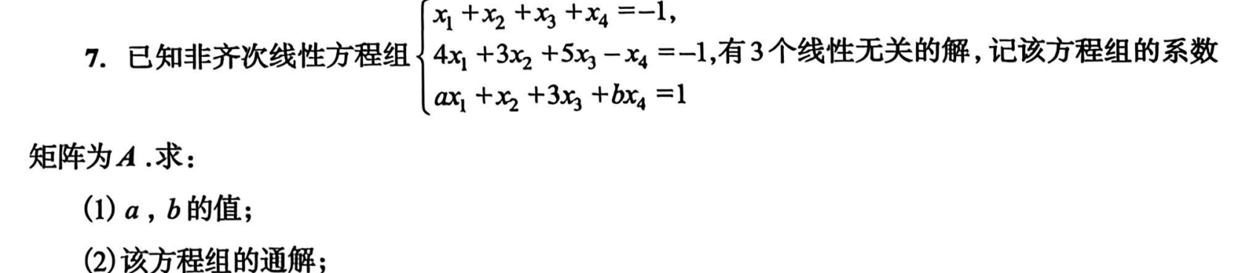
https://chatgpt.com/g/g-p-6a1d6c6f0a408191a175c887909fceb5-xian-dai-he-gai-lu-lun-ocr/c/6a75bdc3-ddf0-83e8-97c3-a848e4bf674a

题3：
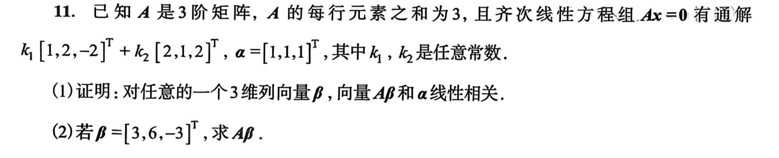
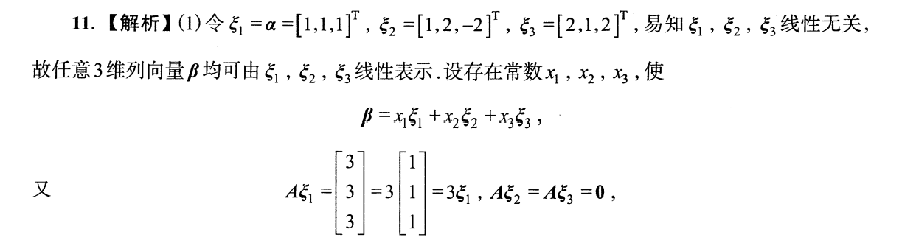
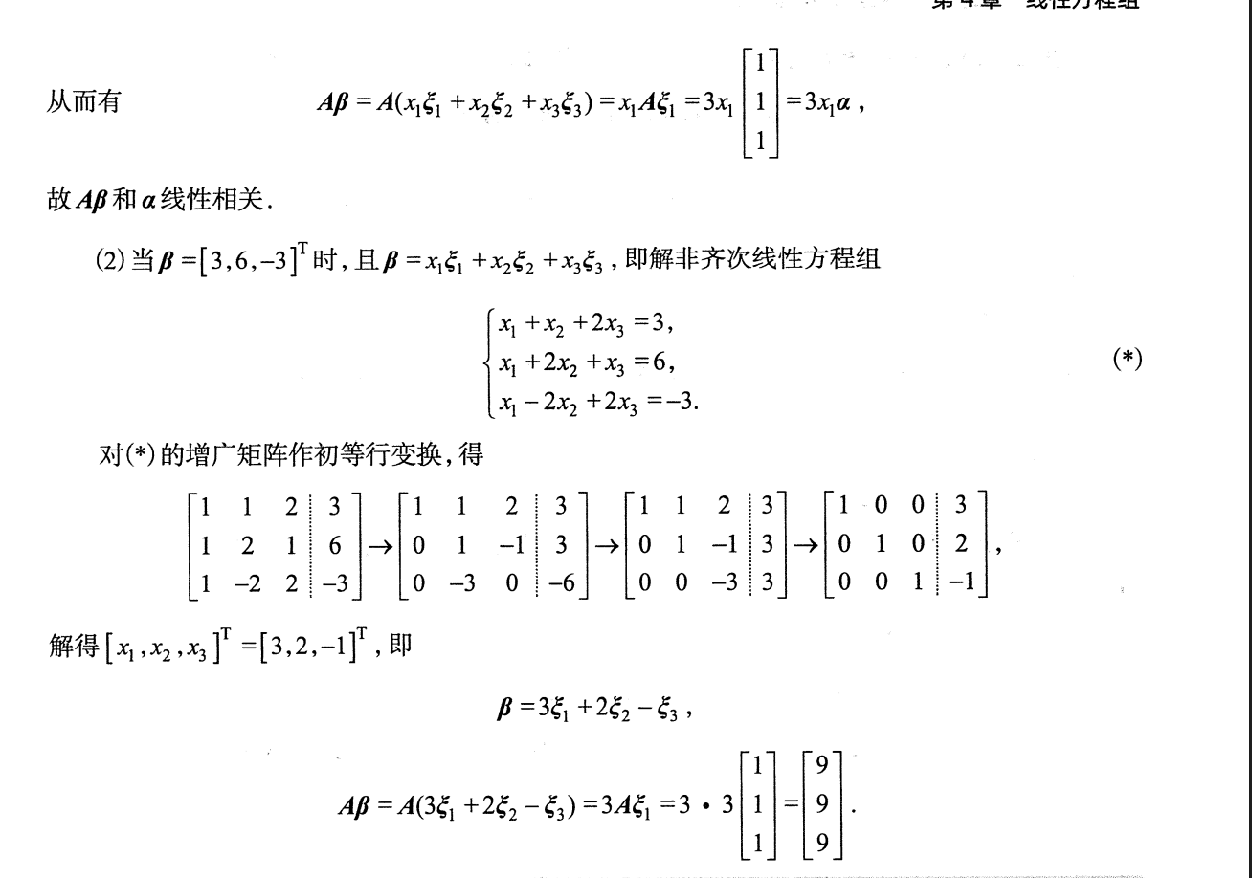
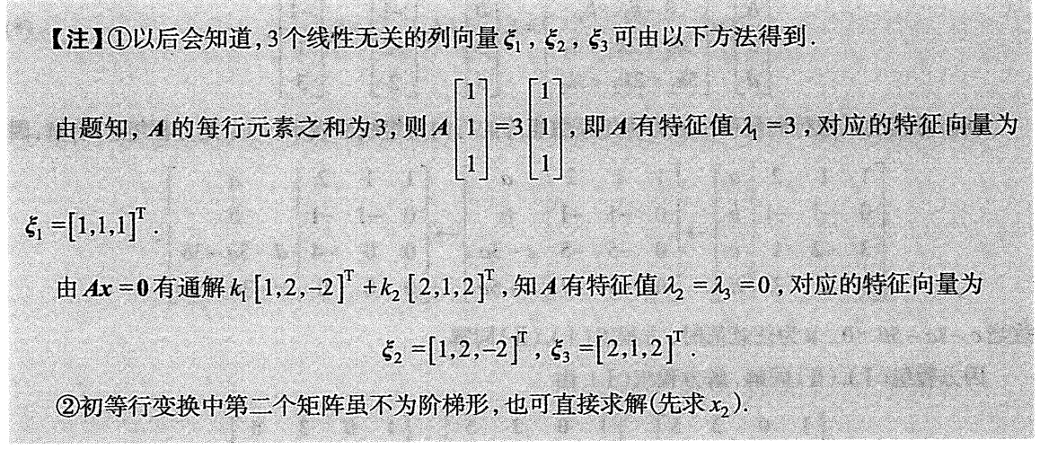
https://chatgpt.com/g/g-p-6a1d6c6f0a408191a175c887909fceb5-xian-dai-he-gai-lu-lun-ocr/c/6a78388d-ff78-83ee-ba4c-43957a264803

题4：
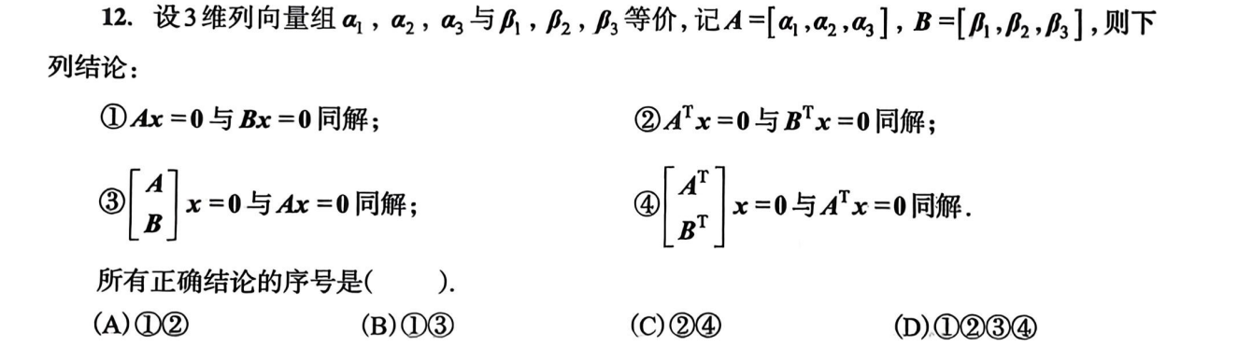
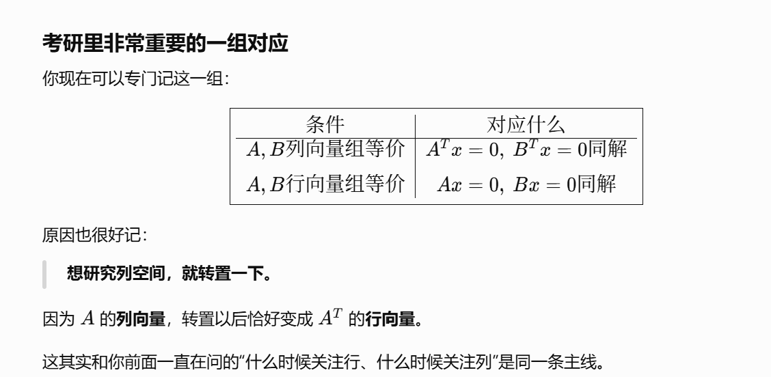
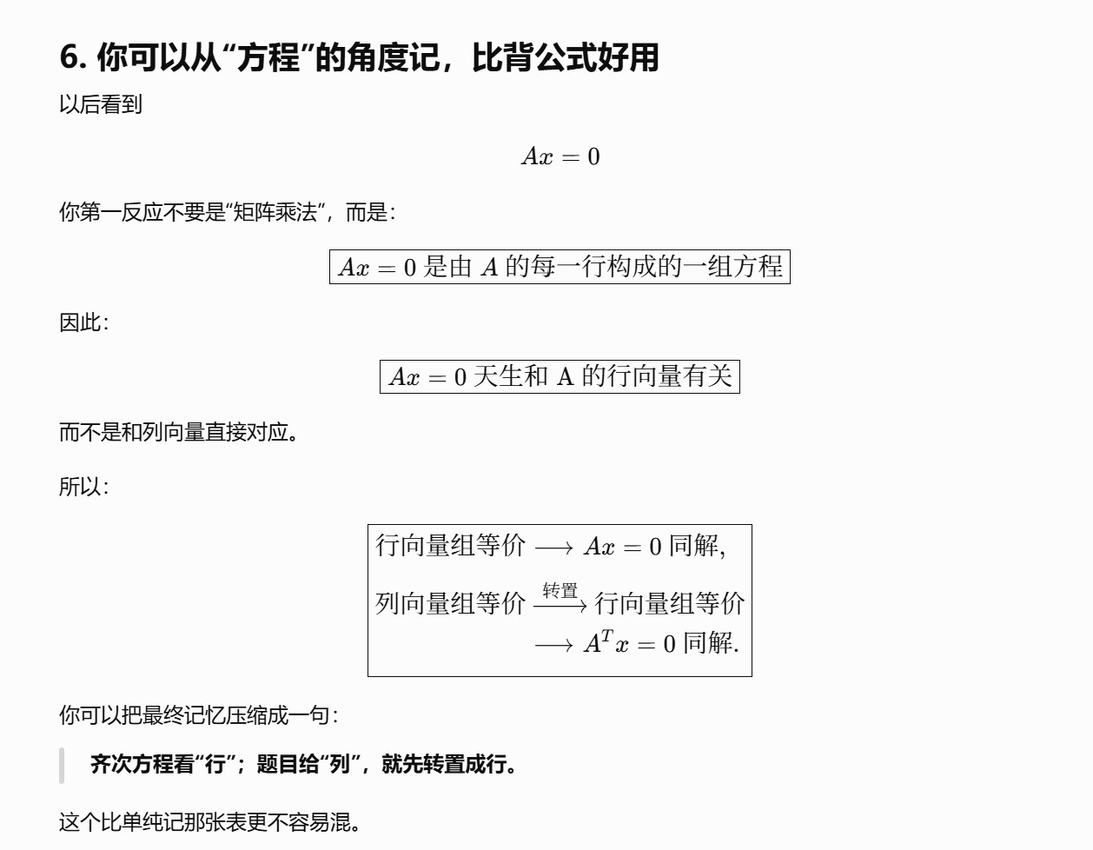
https://chatgpt.com/g/g-p-6a1d6c6f0a408191a175c887909fceb5-xian-dai-he-gai-lu-lun-ocr/c/6a784147-681c-83ee-9e0b-92375cec6ae0

题5：
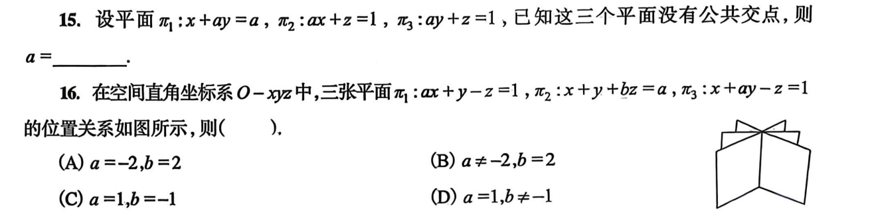
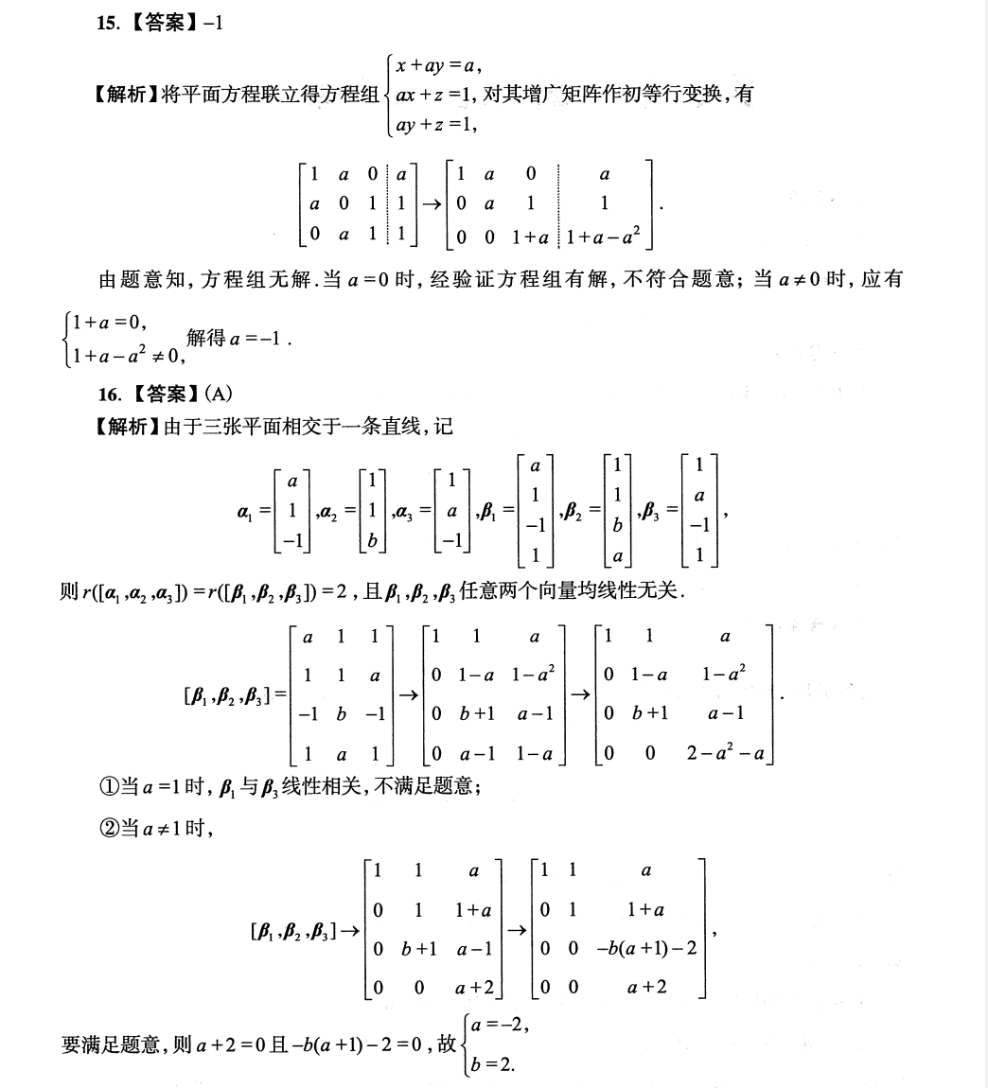

题6：
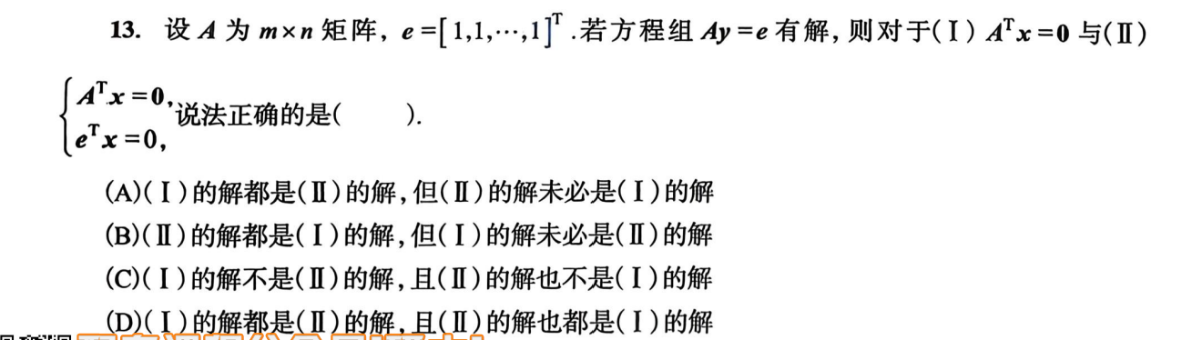
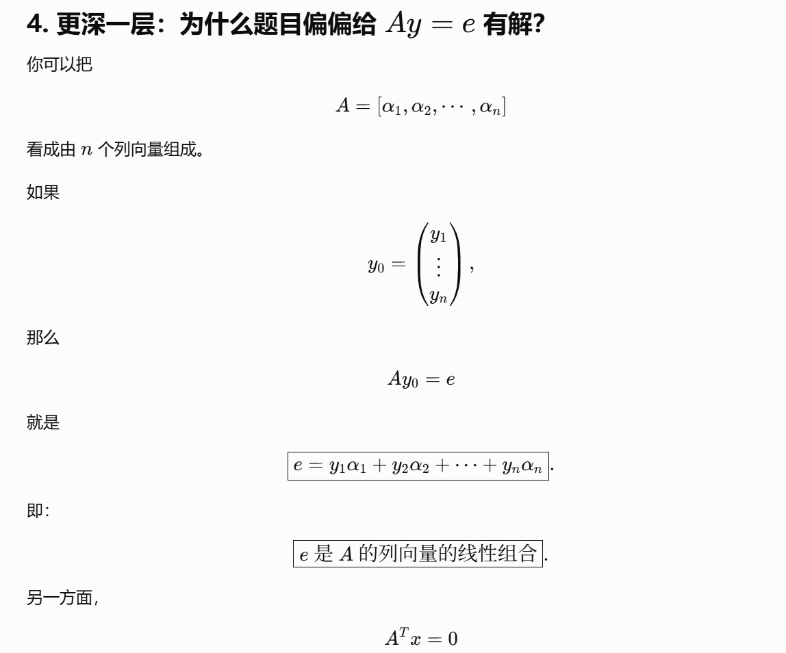
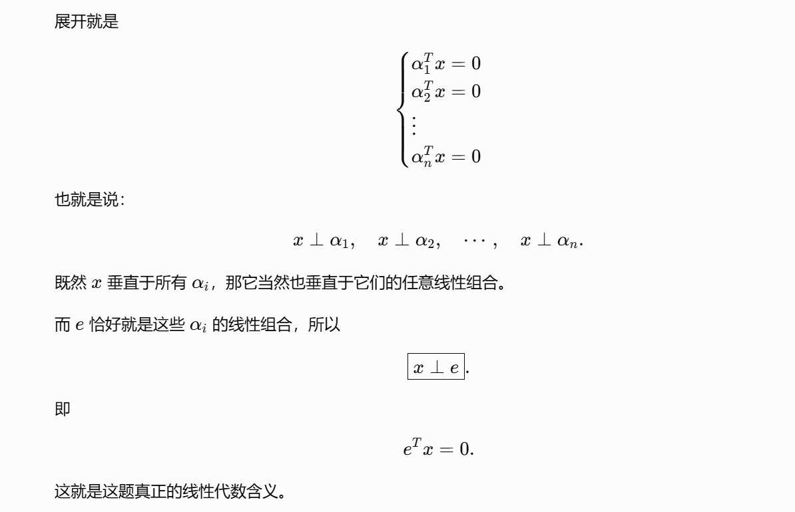
https://chatgpt.com/g/g-p-6a1d6c6f0a408191a175c887909fceb5-xian-dai-he-gai-lu-lun-ocr/c/6a805663-b1a4-83e8-8ee9-c7902644ce1d
|（注：部分内容可能由 AI 生成）

